# **Practical – 4_2**

**Aim: Write a program to compute summary statistics with use of two variability tricks Kurtosis and Skewness in 100 rows of Dataset.**

* Code:

import pandas as pd

import matplotlib.pyplot as plt

import numpy as np

data_set = pd.read_csv("/content/drive/MyDrive/temp/practical_4_2.csv")

df = pd.DataFrame(data_set)

num_data = df.select_dtypes(include=["int64", "float64"])

stats = {

"skewness": num_data.skew(),

"kurtosis": num_data.kurtosis()

}

stats_table = pd.DataFrame(stats)

print("Result\n")

print(stats_table)

fig, axes = plt.subplots(1, 2, figsize=(22, 8))

# ! skewness bar chart

axes[0].bar(stats_table.index, stats_table["skewness"], color="skyblue")

axes[0].set_ylabel("Skewness")

axes[0].set_title("Skewness of Features")

axes[0].tick_params(axis="x")

# ! Kurtosis histo Chart

axes[1].hist(stats_table["kurtosis"],bins=10, edgecolor='black', alpha=0.7)

axes[1].set_ylabel("Kurtosis")

axes[1].set_title("Kurtosis of Features")

axes[1].tick_params(axis="x")

plt.tight_layout()

plt.show()

* 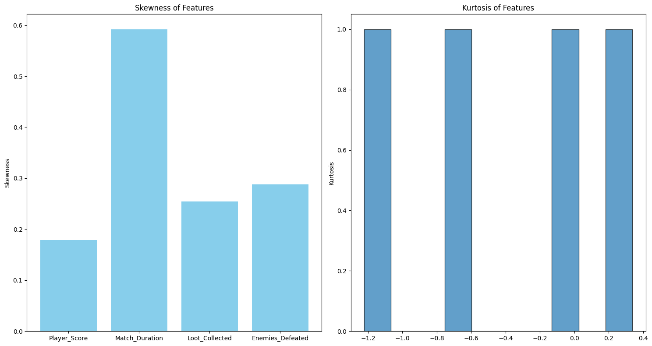Output:

Faculty Signature: _______________ Date: _____________________